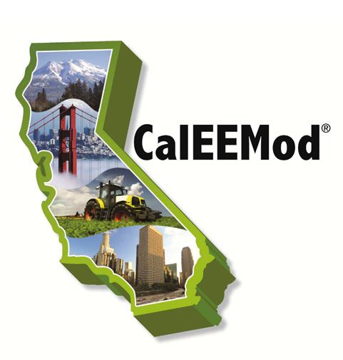 | You have been INVITED to the CalEEMod Update Workshop!  The South Coast Air Quality Management District (SCAQMD) will host a workshop regarding the latest California Emission Estimator Model (CalEEMod) update on February 12, 2014 at the SCAQMD headquarters. CalEEMod has recently been updated to include the latest emission factors from the California Air Resources Board (CARB) and U.S. EPA; updated defaults; increased speed; quantification of off-road equipment emissions during operation; energy use from parking structures; and a new separate mitigation report.  The User’s Guide has also been updated to explain the new features, provide enhanced guidance, and offer visual graphic aids to assist in understanding the functionality of the model. Appendix A has also been updated to include the new equations and corresponding methodologies applied. Appendix D has been revised to include the updated default data and Appendix E has been expanded to document the derivation of new defaults and calculation methodologies of the new features.  The latest CalEEMod v.2013.2.2 modeling files along with the list of revisions, an updated User’s Guide with its corresponding appendices, and modified User's Tips are available free of charge on the CalEEMod website ( www.caleemod.com ).
Wednesday, February 12, 2014
9:30 - 11:30 am
SCAQMD Auditorium
21865 Copley Drive
Diamond Bar, CA 91765

The workshop will be webcast and offsite participants can submit questions (inquiry@caleemod.com) to be answered during the workshop.

